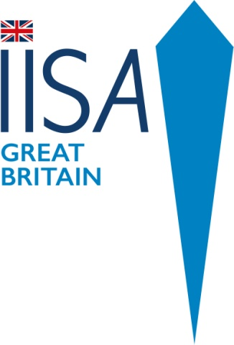
IISA GB Championships 5 & 6 January 2019
Hatfield Activity Centre, Hatfield, Yorkshire

Event Brochure and Important Information

Draft Programme
Sat 5th January
1000m Event (£65) Maximum time permitted 30 minutes. Must meet qualification criteria to be accepted.
Sun 6th January
- 500m Freestyle (£35) Maximum time permitted 15 minutes.
20 minute break
- 50m Breastroke (£15)
- 100m Freestyle (£15)
- 100m Individual Medley (£15)
Lunch Break / Raffle / Prizes
- 250m Freestyle (£20). Maximum time permitted 10 minutes.
Please enter on the IISA website for the 200m freestyle. There is not an option on the website for 250m unfortunately. Selection for the IISA GB Country relay team 4 x 250m at the 3rd Ice Swimming World Championships in Murmansk 2019 will be based predominantly on this event. (To qualify – you must be swimming in other events either as part of team GB for the 1000m or shorter distances in the Arctic Cup.
- 4 x 50m freestyle relay. (£40 per team)
Team must comprise of at least one man and one woman.
- 4 x 25m fun relay (£40 per team)

Important Notes:
The event will run in accordance with the rules and regulations of IISA.
Entries: Please enter via IISA website on events page https://www.internationaliceswimming.com
Entries Open 6 November 2018 and close 16 December 2018 or sooner if full.
Payment PayPal : https://paypal.me/IISAGB
Unfortunately no refunds will be given due to the high costs IISA GB Incurs in organising an event.
Any swimmer who is stopped by the referee and refuses to leave the water will be disqualified and not permitted to swim in any other events during the weekend.
For the 1000m: Swimmers who have completed less than half the distance at 15 minutes will be given a warning. Any swimmer with more than 4 lengths remaining (100m) at 27 minutes, will be stopped (and a DNF recorded).
Qualification for the 1000m
Please see IISA Rules : https://www.internationaliceswimming.com/wp-content/uploads/2018/10/IISA-Qualifying-Swims.pdf
You must have had an ECG and medical within 6 months of the swim. Please print out medical form here and take to your GP/ Doctor https://www.internationaliceswimming.com/wp-content/uploads/2018/10/IISA-Medical-Assesment-Form.pdf
Qualification for 500m:
Swimmers do not need an ECG or medical. You do however need to have completed a qualifying swim of 400m at 5C or under; 500m at 6C or 650m at 7C. Please bring a paper copy / print out of your qualifying swim from your IISA bio page. You may be asked to show this at registration.

If anyone who wishes to compete has a disability or serious medical condition please email IISA-GB@outlook.com asap so this can be discussed with the medical officer. IISA GB will make reasonable adjustment providing it does not compromise the safety of the overall event or any individual competitor.

Further more detailed information will be sent to competitors prior to the event.

