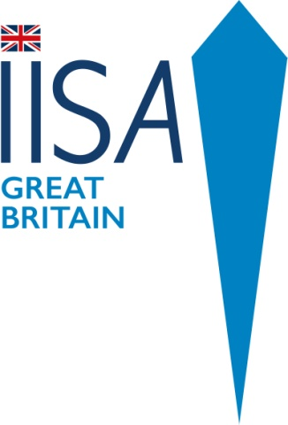
IISA GB Championships 11 & 12 February 2023
Sandford Lido, Cheltenham – 50m pool

Event Brochure, Draft Programme and Important Information

Draft Programme
Sat 11 February
1000m Event (£65) Maximum time permitted 30 minutes. Swimmers must meet IISA qualification criteria to be accepted.
50m Breaststroke (£20)
Sun 12 February
- 500m Freestyle (£35) Maximum time permitted 15 minutes.
- 100m Breaststroke (£20)
- 100m Freestyle (£20)
- 250m Freestyle (£25). Maximum time permitted 10 minutes.
- 4 x 50m Relay (£40 per team)

Selection for Team GB at next IISA World Championships
We will be using the GB Championships 2023 as a critical event for selection to represent Great Britain in the next IISA World Championships and therefore strongly recommended those who wish to be considered attend.

Important Notes

The event will run in accordance with the rules and regulations of IISA.
Entries: Please enter via IISA website on events page https://internationaliceswimming.com/events-calendar/
Entries Open 20 November 2022 and close 31 December 2022 or sooner if full. Entries must be paid for when entering and by 31 December at the latest. Please pay by bank transfer to:

Account: International Ice Swimming Association Great Britain
Bank: Lloyds Bank
Sort Code: 30-98-97
Account Number: 36305168
Please make sure you use your name (as registered on IISA) as reference
Unfortunately no refunds will be given due to the high costs IISA GB incurs in organising an event.
Please familiarise yourself with IISA swimming rules.
Any swimmer who is stopped by the referee and refuses to leave the water will be disqualified and not permitted to swim in any other events during the weekend.
For the 1000m: Swimmers who have completed less than half the distance at 15 minutes will be given a warning. Any swimmer with more than 2 lengths remaining (100m) at 27 minutes, will be stopped (and a DNF recorded).
Qualification for the 1000m
You must have had an ECG and medical within 6 months of the swim. Please print out medical form here and take to your GP/ Doctor
https://internationaliceswimming.com/iisa-rules/
Qualification for 500m:
Swimmers do not need an ECG or medical. You do however need to have completed a qualifying swim of 400m at 5C or under; 500m at 6C or 650m at 7C. Please bring a paper copy / print out of your qualifying swim from your IISA bio page. You may be asked to show this at registration.

If anyone who wishes to compete has a disability or serious medical condition please email IISA-GB@outlook.com asap so this can be discussed with the medical officer. IISA GB will make reasonable adjustment providing it does not compromise the safety of the overall event or any individual competitor.

Further more detailed information will be sent to competitors prior to the event.

